**Extra Credit:**

1. Changed Website’s Look and Feel.

* Added a background.
* Aligned some of the tables.
* Added a warning pop up for services and products as a confirmation before being deleted. Earlier they were being deleted without a confirmation.

1. Added Change Password Functionality in admin view in Django.
2. In customer summary, Customer Total would not be correct if no service charge was added. Fixed that to accurately pick both product and service charge and sum them up.

**URL to Github**:   
https://github.com/achandra0/MaverickFoodServiceCRM.git

**URL to deployed website**:

<http://ananyamfscrm.pythonanywhere.com/home/>

**Instructor Login**:  
ID: instructor  
Password: instructor2a

**Few screenshots of unit test environment running on my laptop of the Maverick Food Service (MFS) Customer Relationship Management (CRM) Application and the admin page of the application.**The URL is visible in the screenshots showing localhost (127.0.0.1).

Homepage:

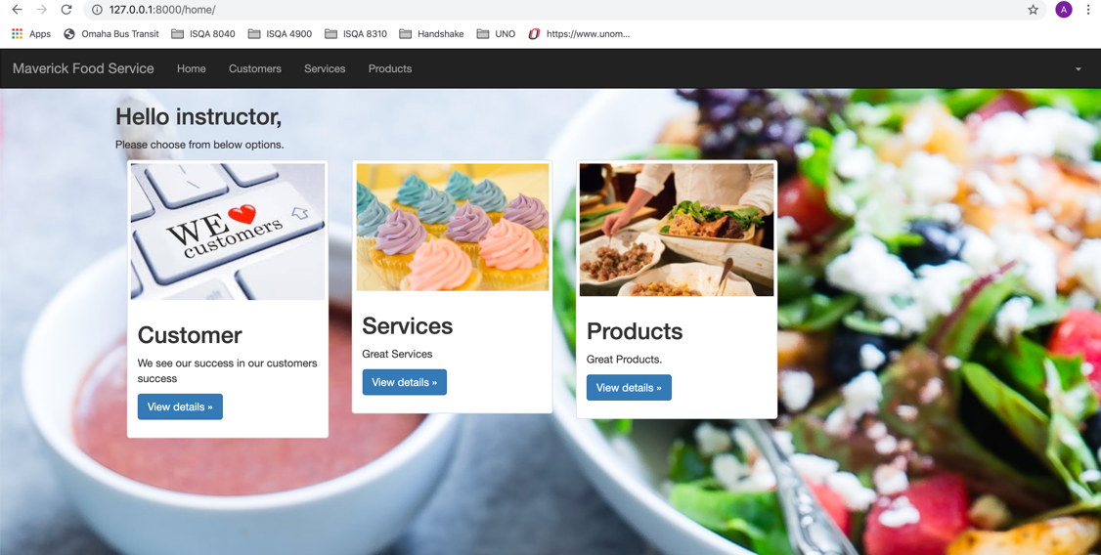

Viewing all customer’s list:

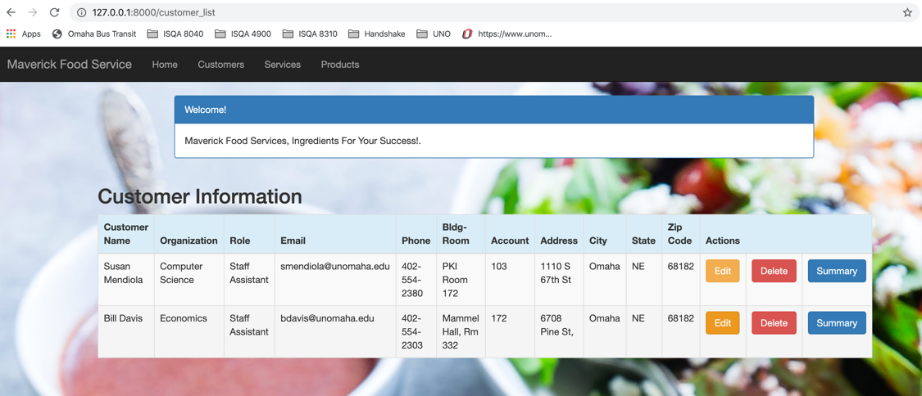

Editing a customer:

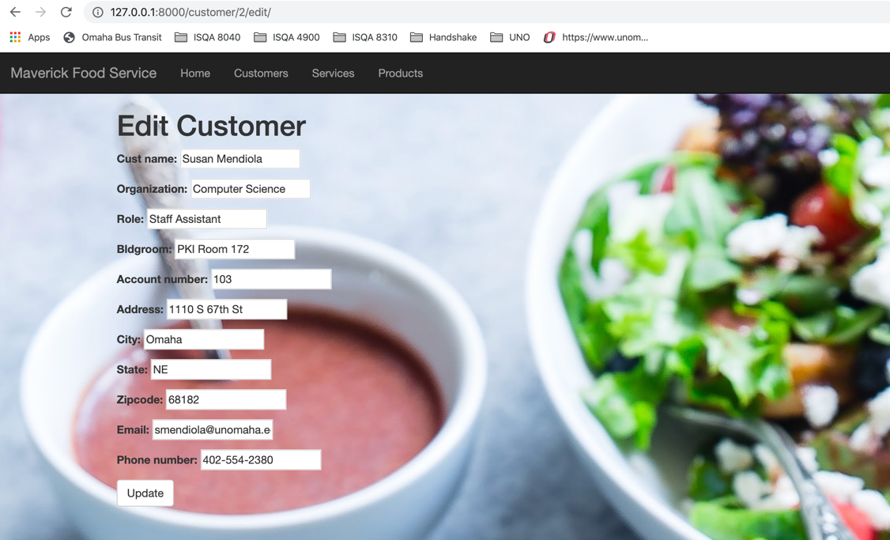

Deleting a Customer:

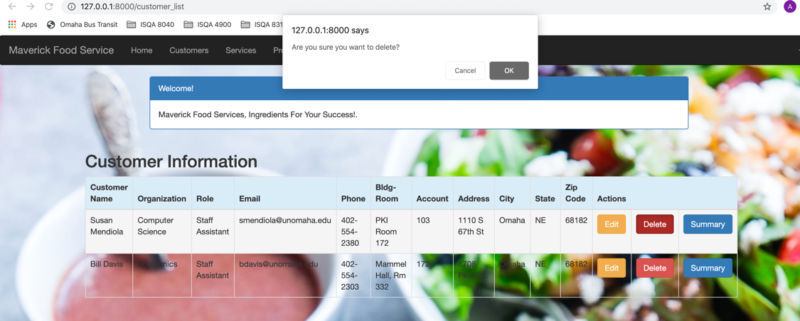

Customer’s Summary with adding up their charges:

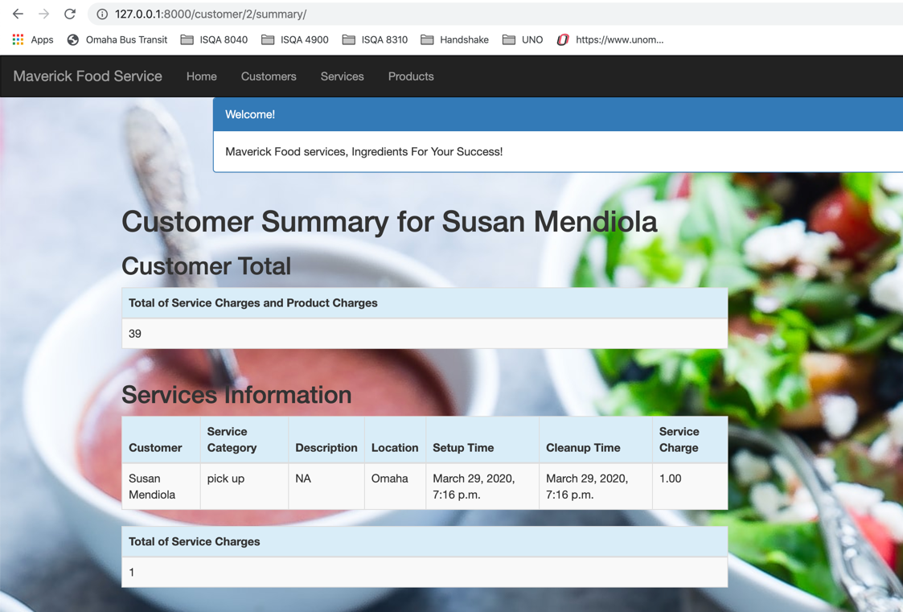

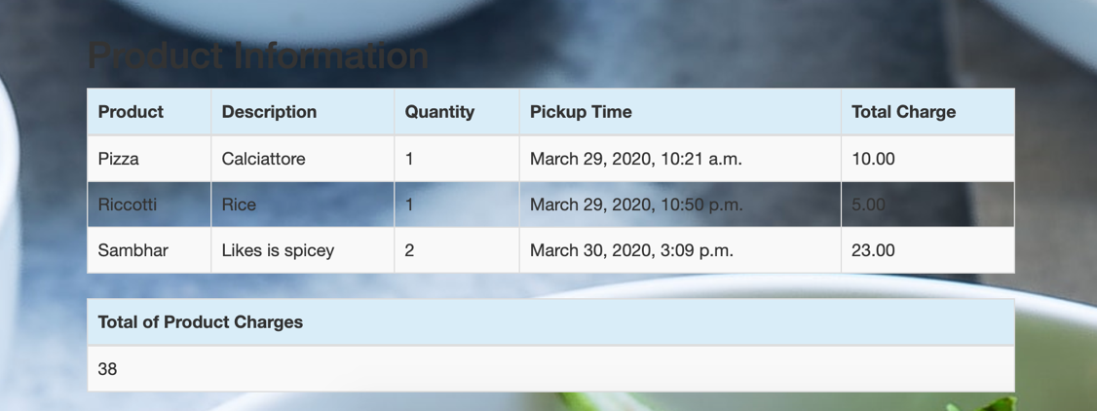

Viewing all Services:

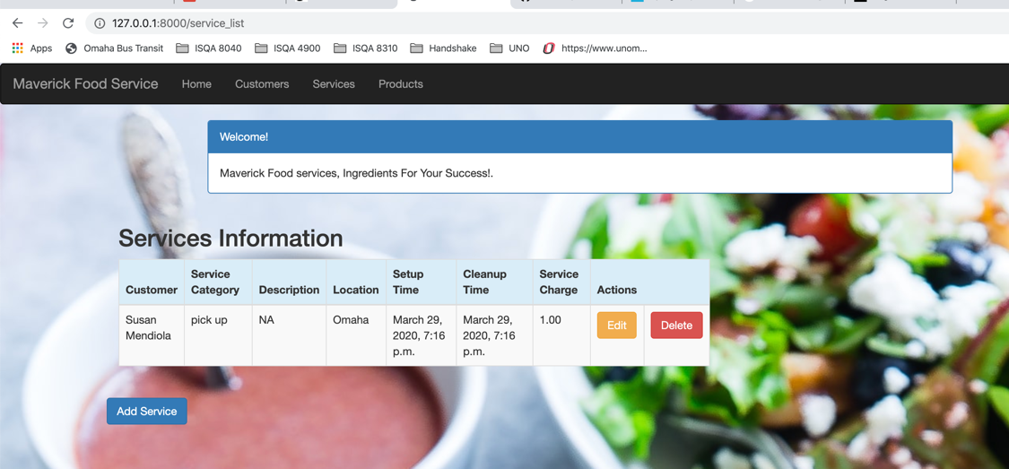

Deleting a service

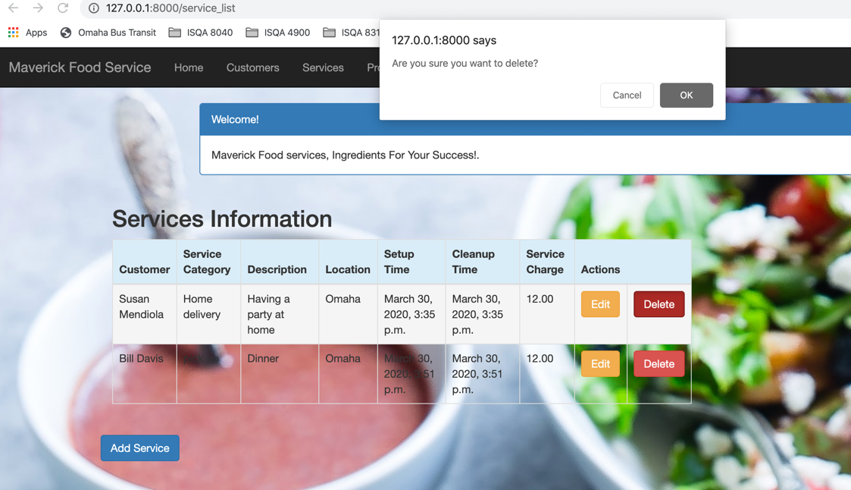

Add a service:

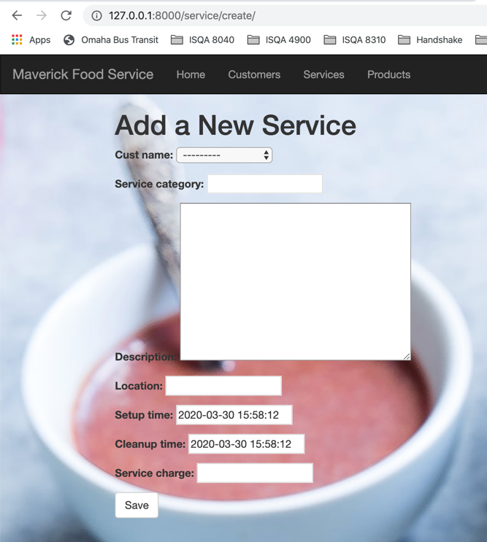

Editing a service:

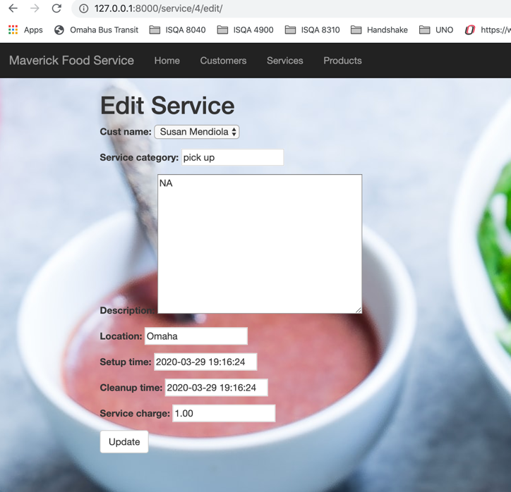

Viewing all products

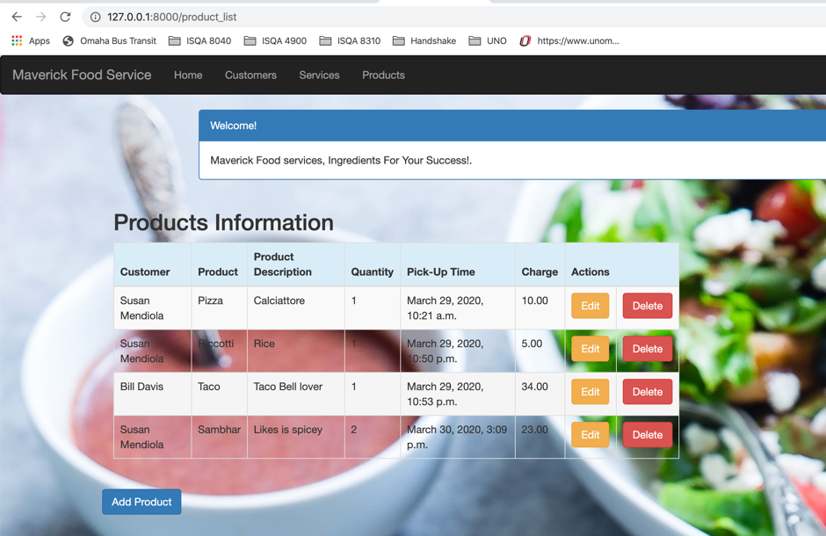

Editing a Product

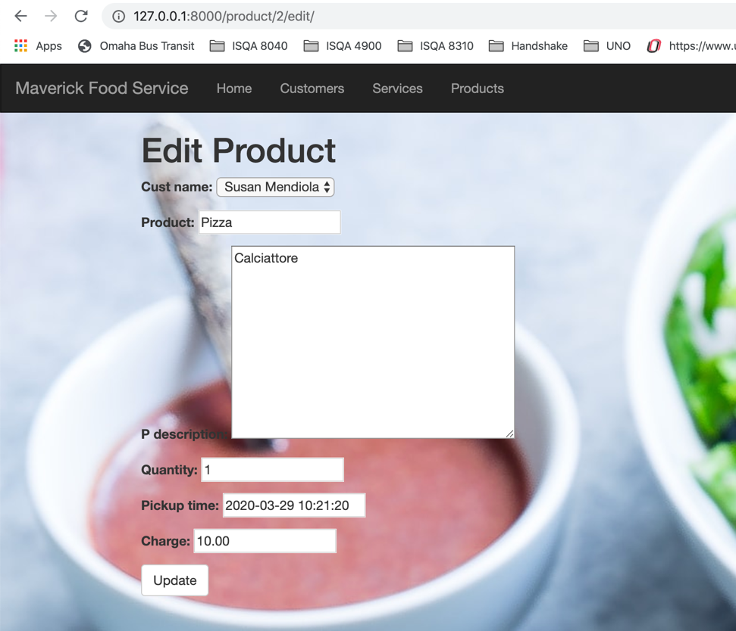

Adding a product

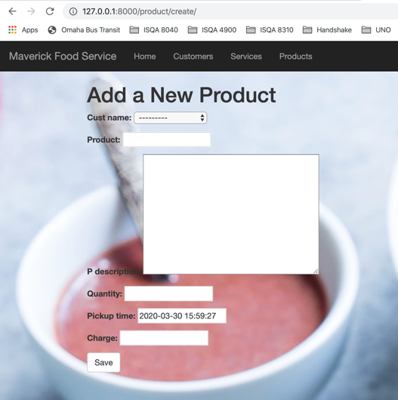

Deleting a product

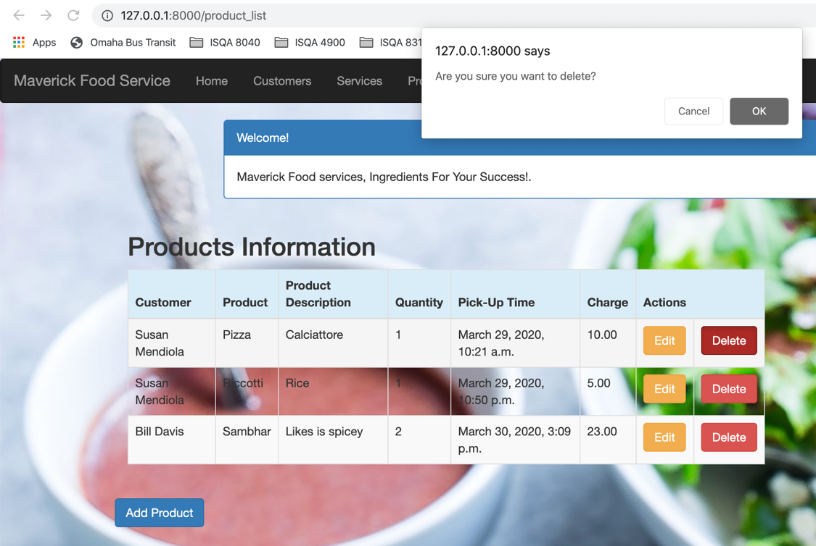

Option to Logout

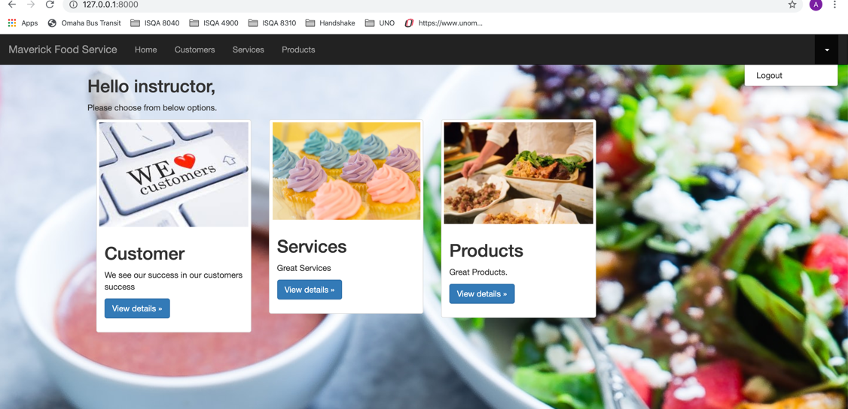

Logged out view of the website

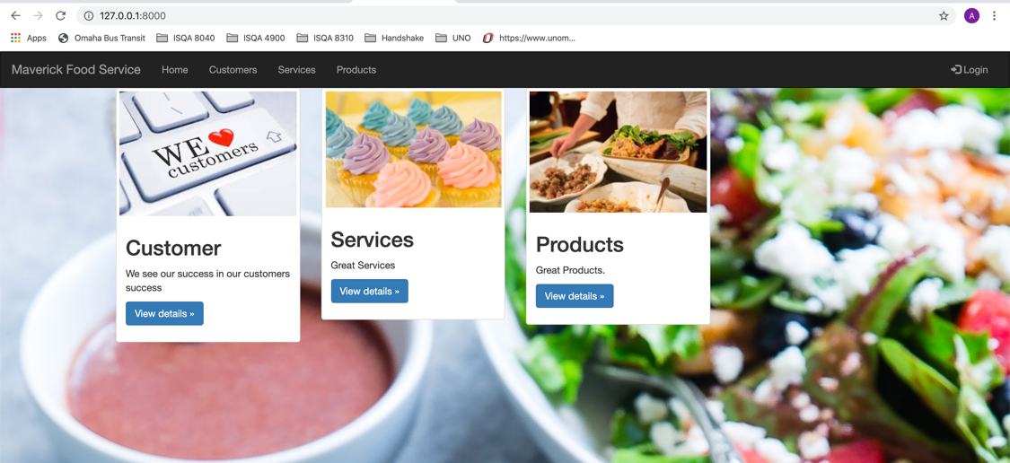

Login Page

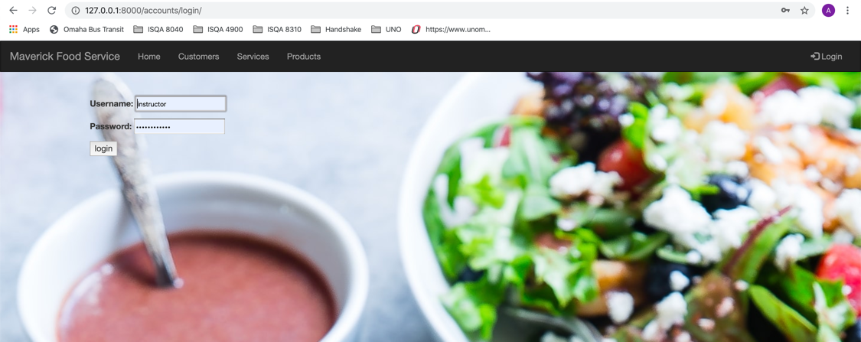

**ADMIN FUNCTIONALITIES:**

Admin Home after logging in.

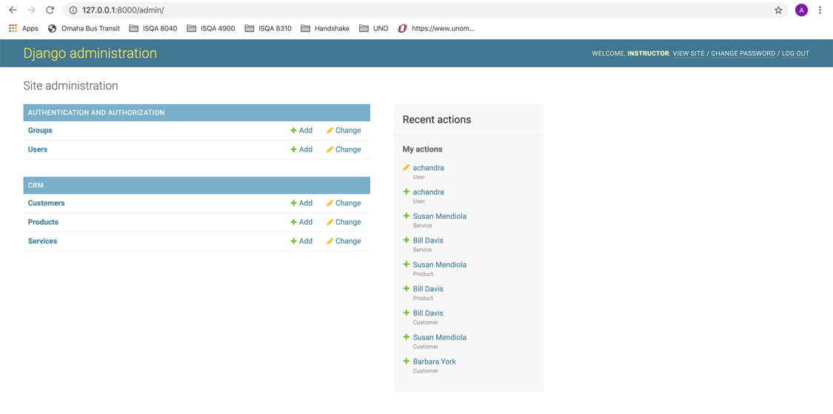

Adding Customer

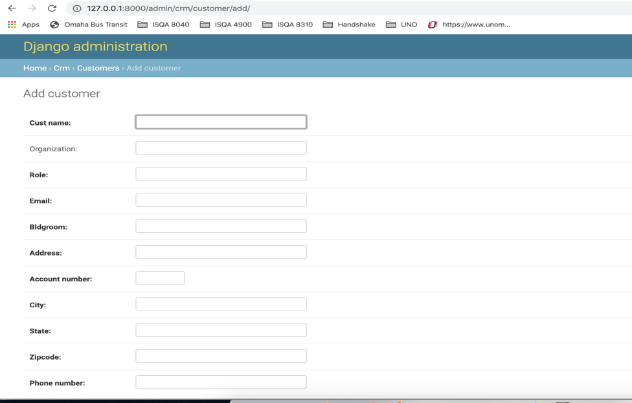

Viewing all customers:

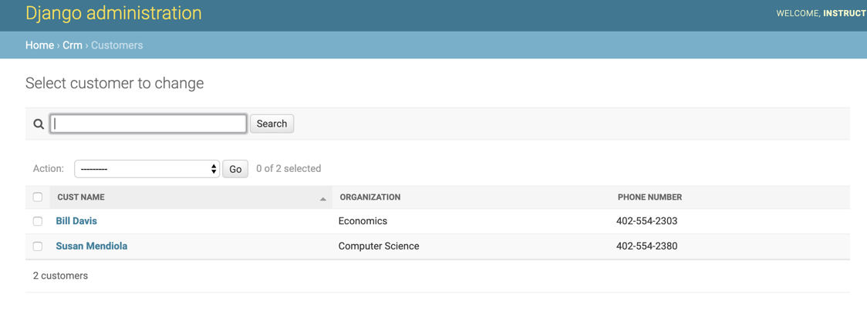

Deleting customers:

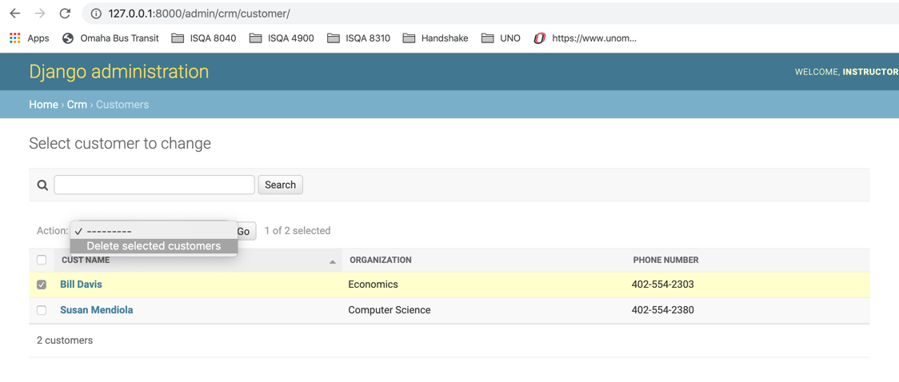

Editing a customer record:

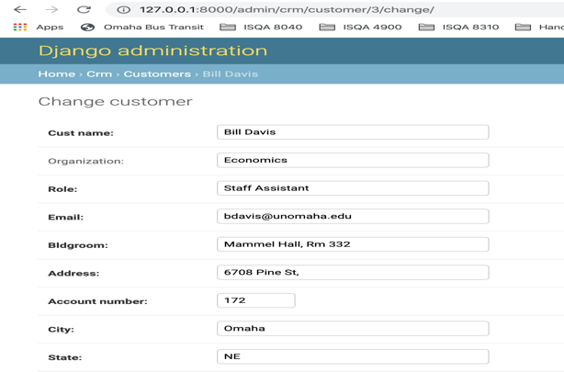

Adding a product:

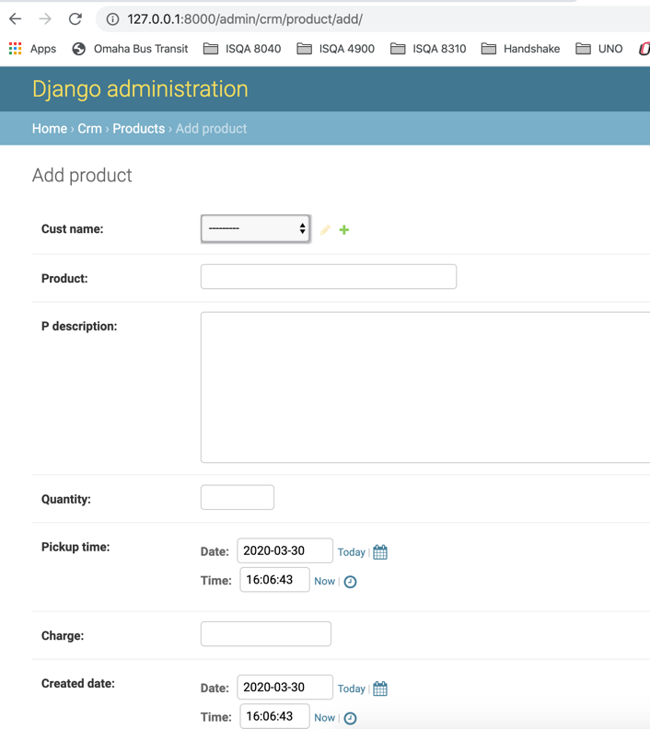

Deleting a product:

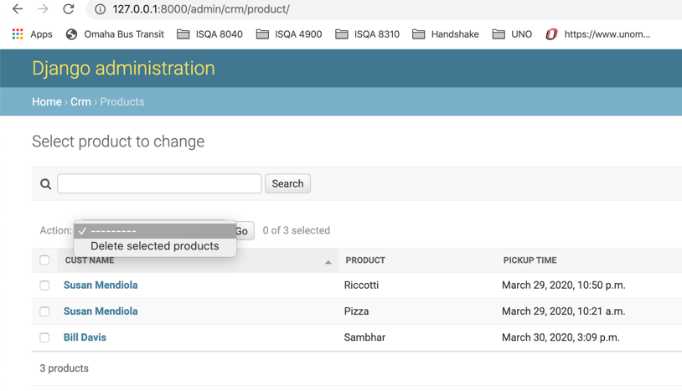

Editing a product:

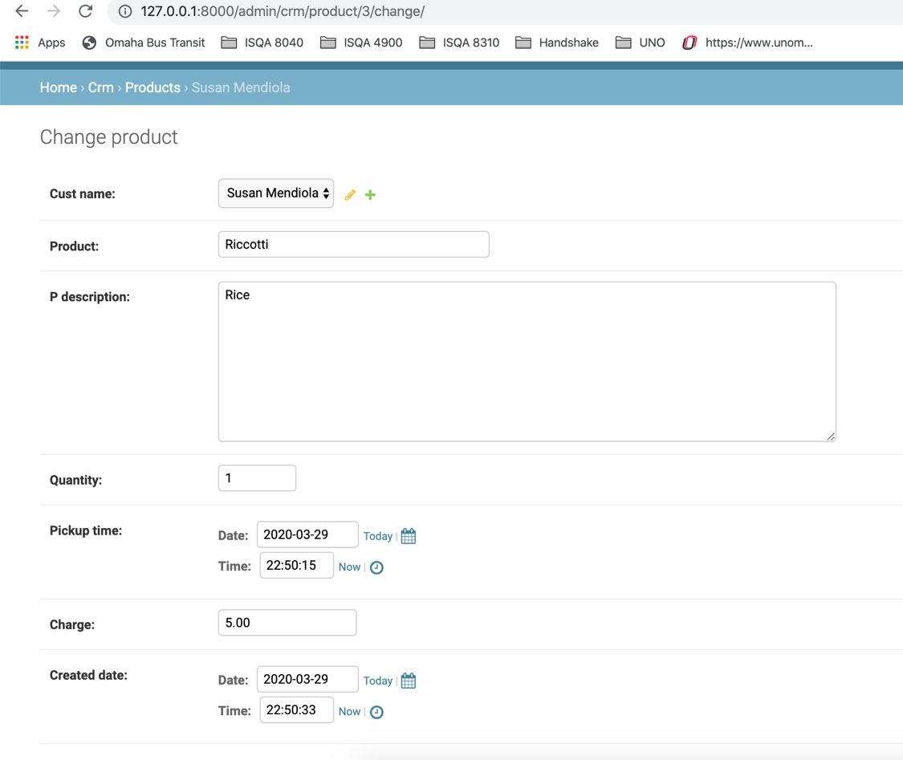

Viewing all products:

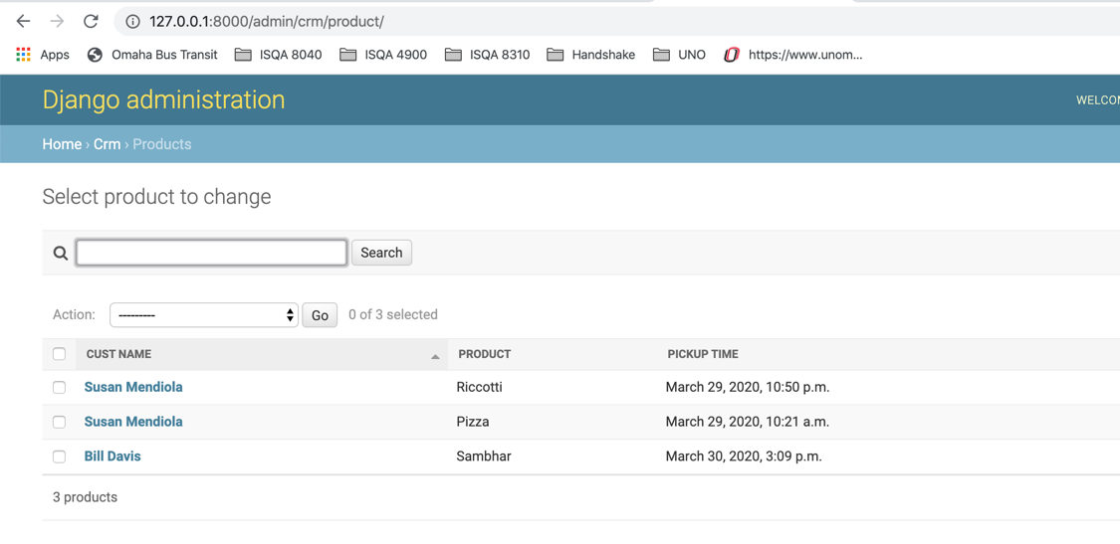

Adding a service:

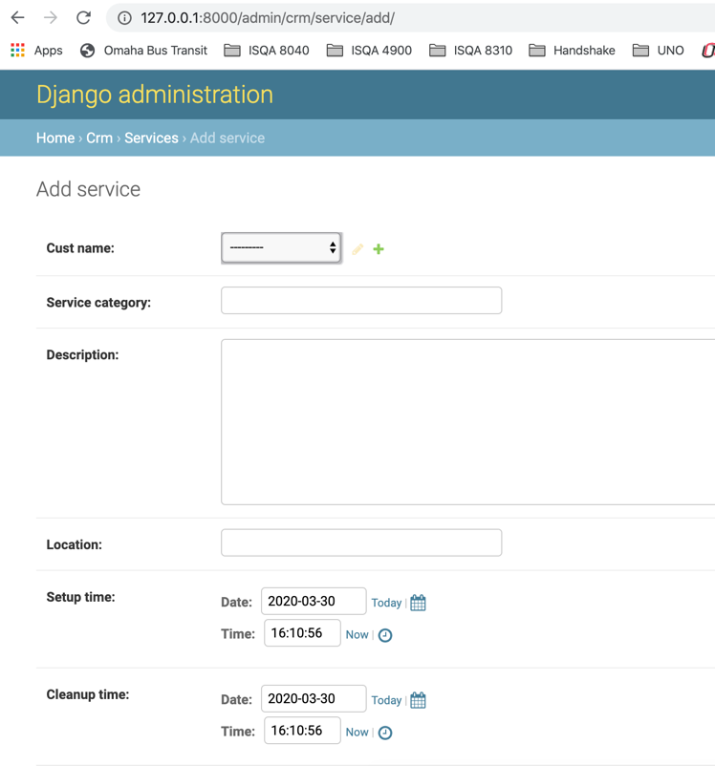

Deleting a service:

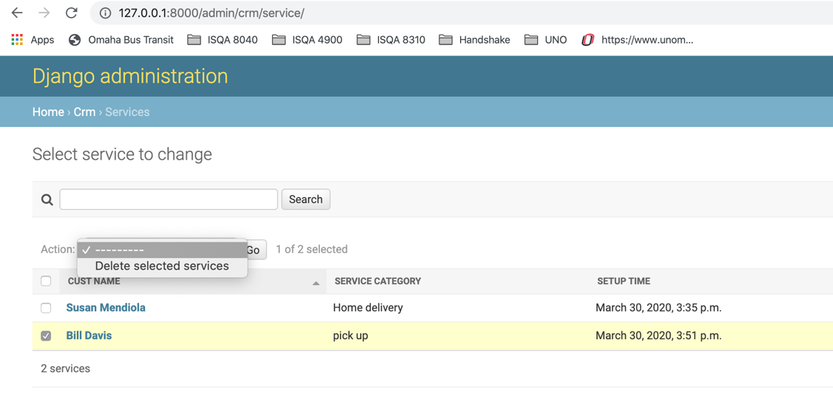

Editing a service:

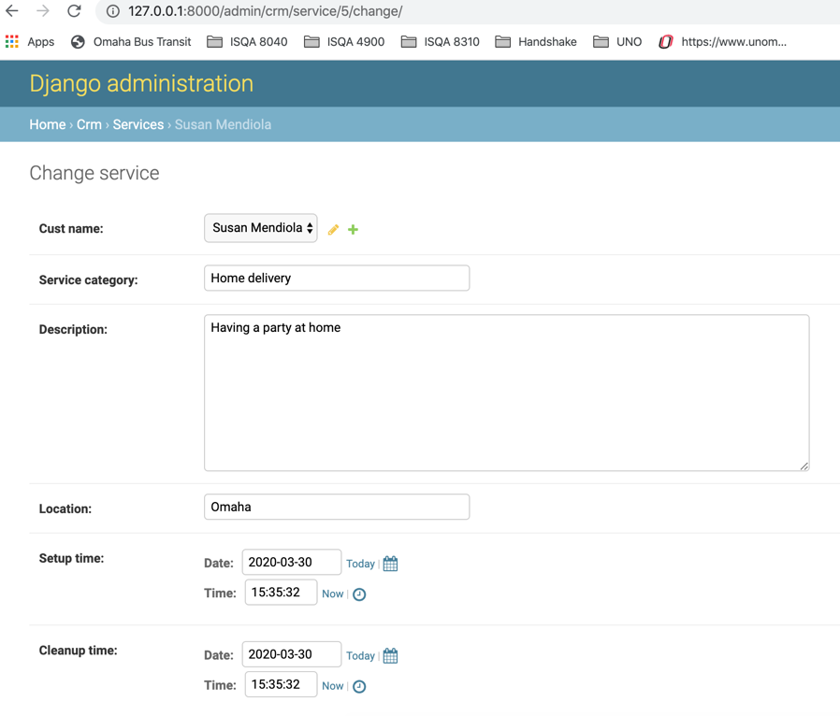

Viewing all services:

